COMPUTER AIDED DESIGN USING ONSHAPE AND SIMSCALE BY TRACY PREST
Design of 3D assembly layout
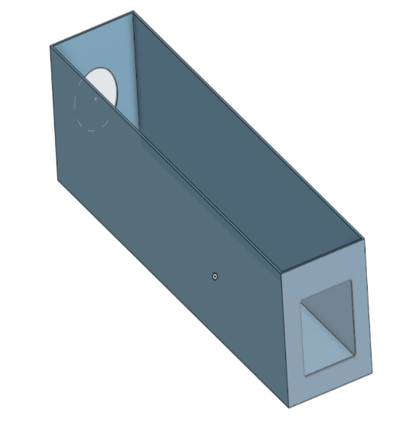
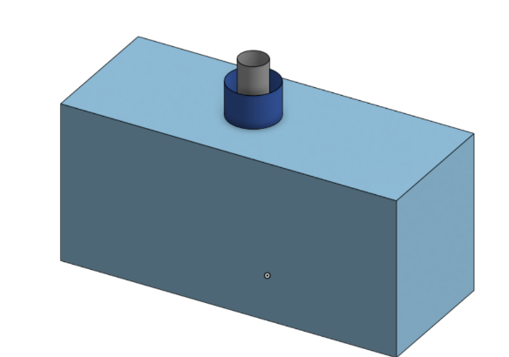
3.0m x 1.2m x 1.4m Engine Block

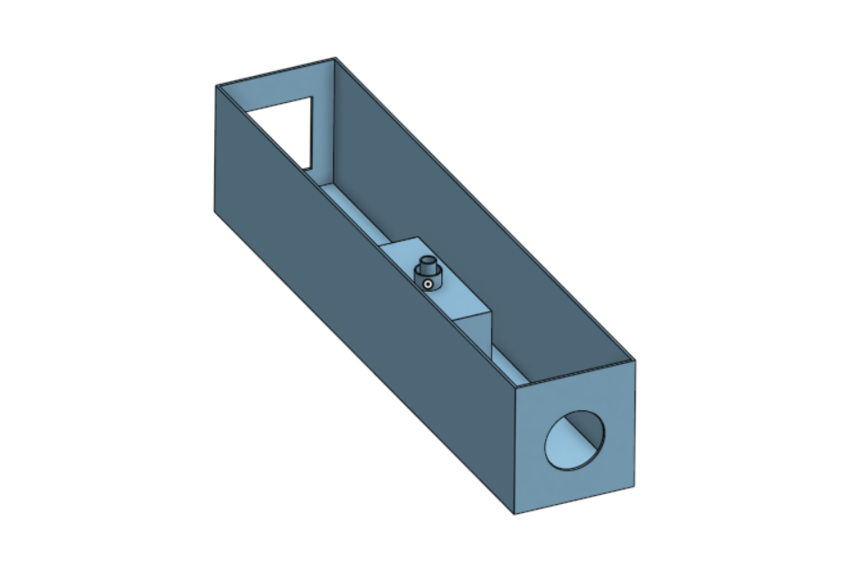
Combined Heat and Power (CHP) Energy Recovery System.

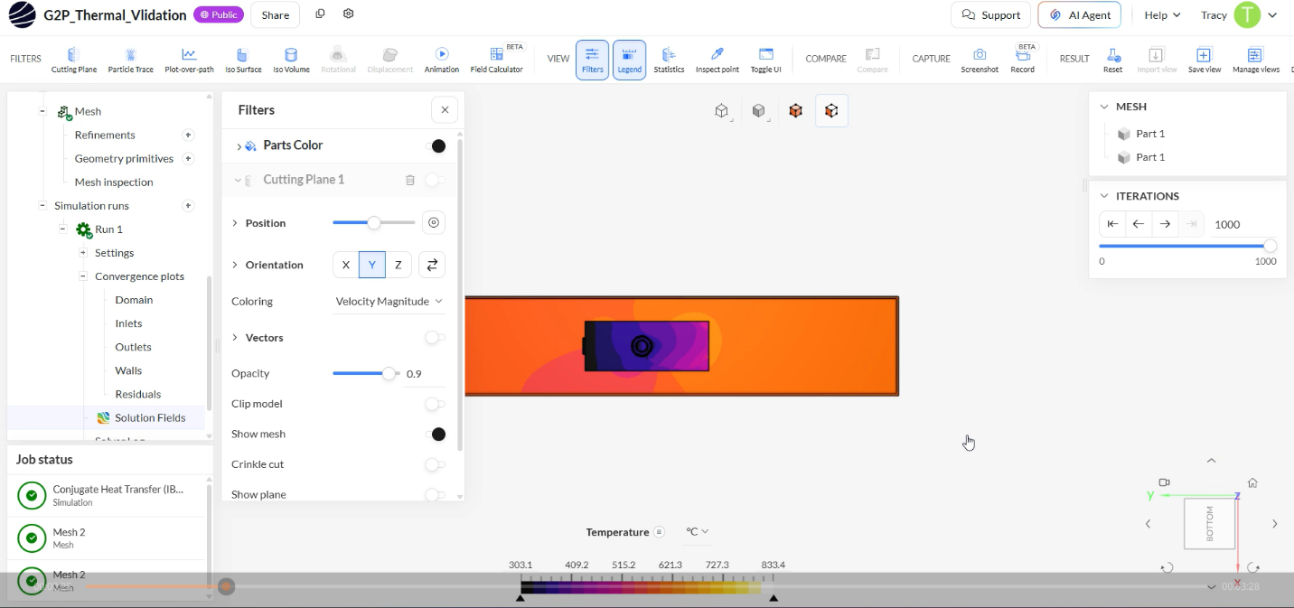
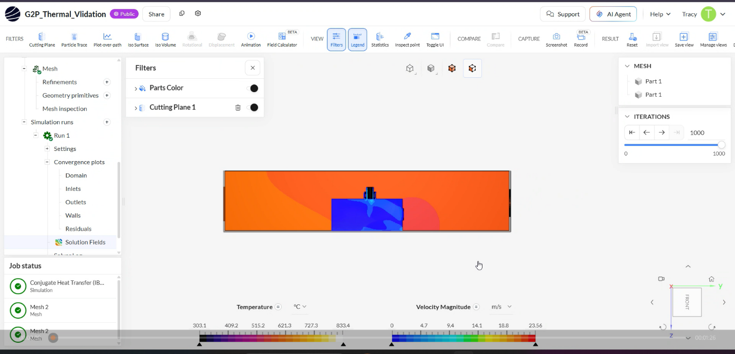

The Gas to Power System in an operational temperature baseline with ambient air at 8 m/s creating a powerful internal sweeping current.
The convective loop successfully prevents thermal trapping, sweeping the 306 kW of engine waste heat cleanly out of the exhaust wind box.
The simulation confirms that internal air temperatures remain safely below the 60°C operational limit, demonstrating that the physical package can reliably operate and withstand extreme ambient conditions.

